**Amazon S3: How to host static websites.**

Step 1:

S3 → create a bucket →

Step 2: download one css template from google and extract it in your local system.

Step 3: Create one bucket → upload css template file in that bucket.

[Note: Move index.html and templates outside]

Step 4: Then go in properties and enable static website hosting.

S3 → bucket → properties → enable website hosting → enable it

Create index.html —> website will host from this file.

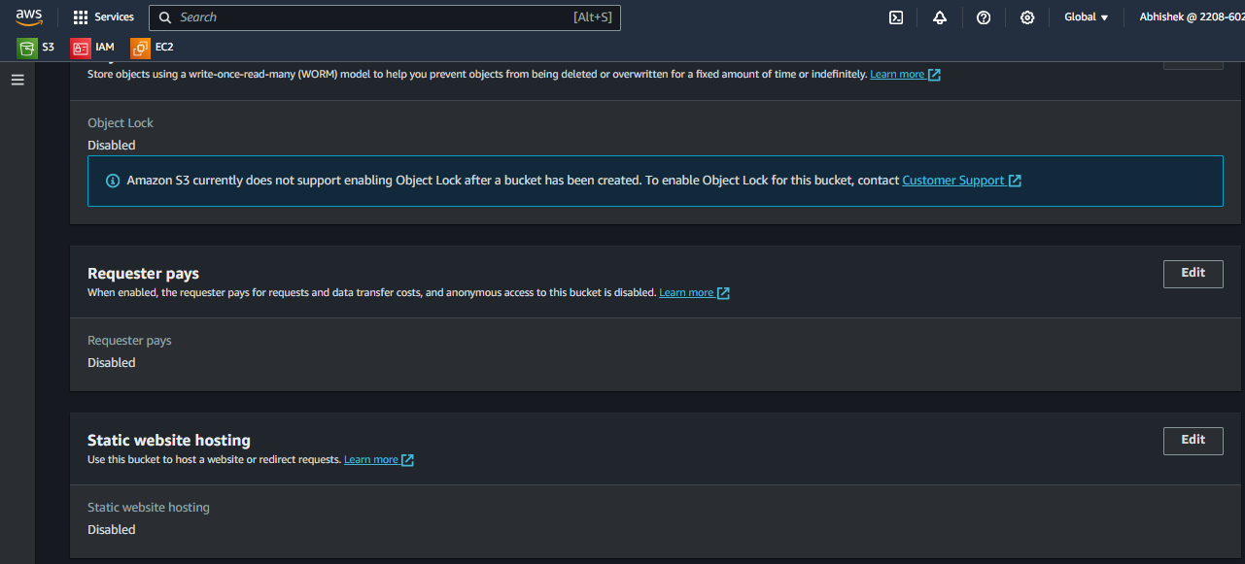

Step 5 : enable permissions.

1. Enable public access.

S3 → bucket → permission → block public access (enable).

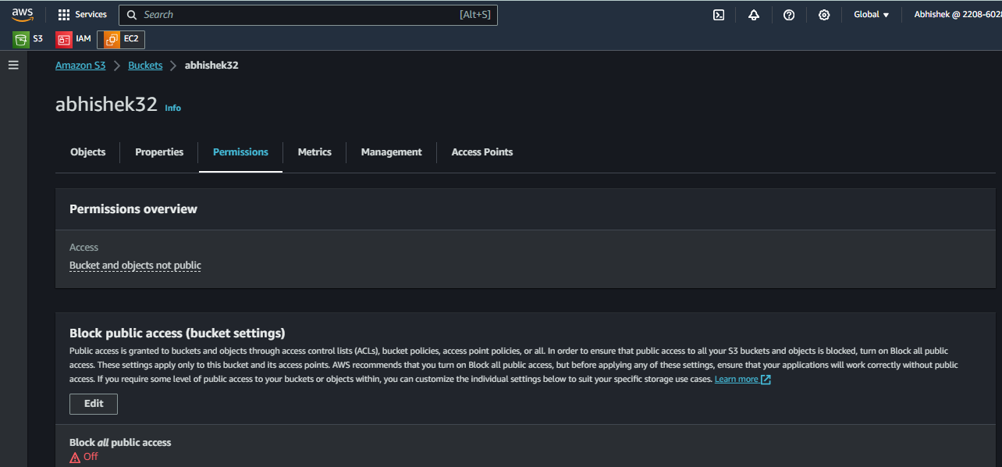

1. Object ownership – do acl enable

S3 → bucket → permission → object ownership → Acl enabled.

1. Edit acl permission make it public.

S3 → bucket → permission → tick acl enable.

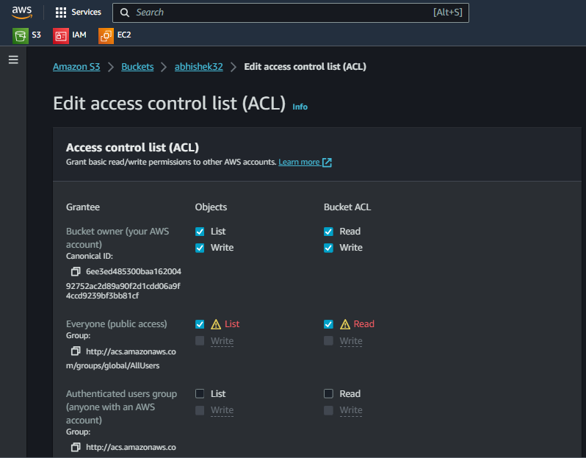

Step 6: Then give public permission to all objects.

S3 → bucket → object → select all objects → security → select make public using CLI.

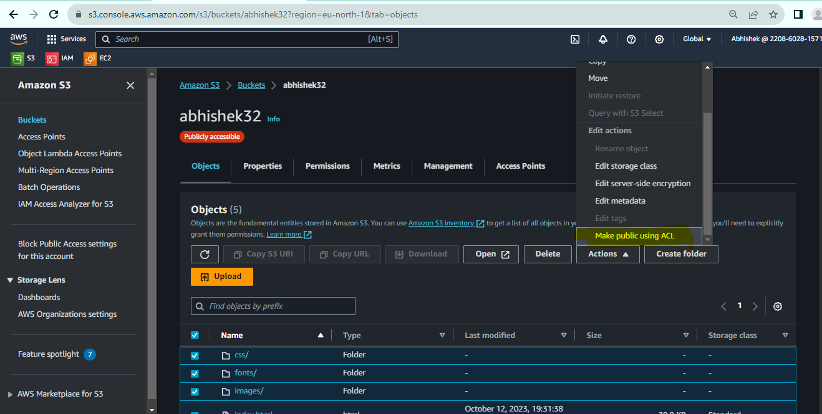

Step 7: Now copy static websit link and paste it on google.

S3 → bucket → object → properties → static website listing → copy link → paste it on google.

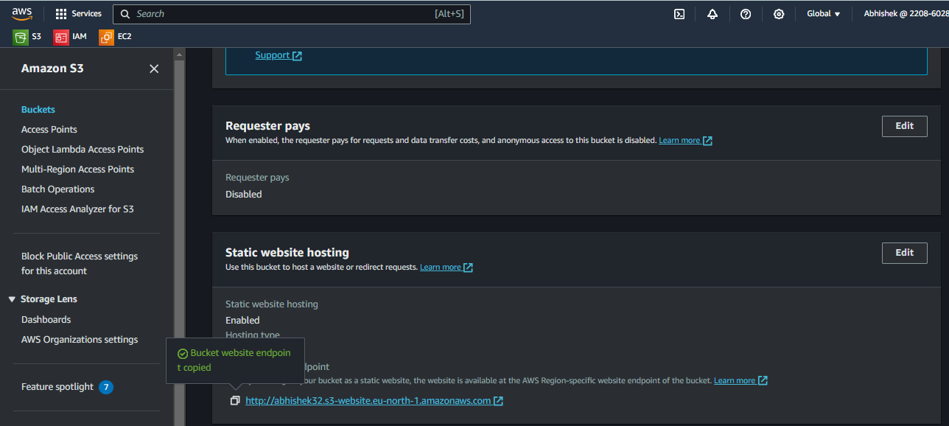

Step 7: If you want to make some changes you can do it. Open “index” file in visual code in local machine and do changes also you can change photos.

Open index file in visual code in local machine→ make changes → save it in local

Step 8: Unable versioning.

S3 → bucket → properties → bucket versioning (enable).

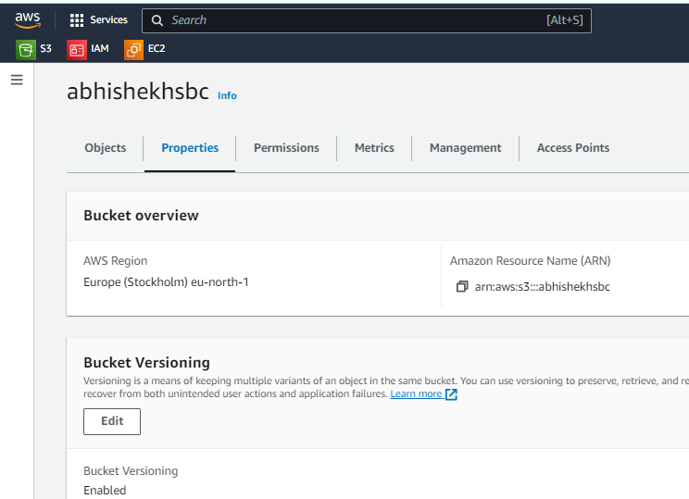

Step 9: Upload index file in bucket, since we enable bucket versioning so new uploaded file will reflect.

S3 → bucket → go to bucket → upload index file.

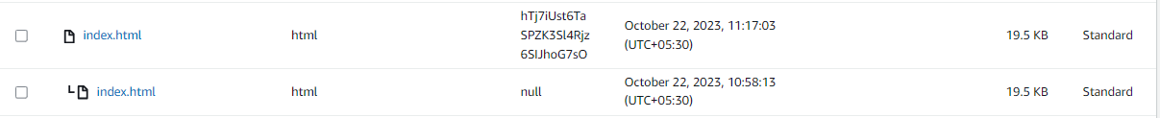

Step 10: Give public permission to uploaded index.html file

S3 → bucket → go to bucket → open index.html → permission → make it public → and then check changes are reflecting or not.(Yes it is reflecting).

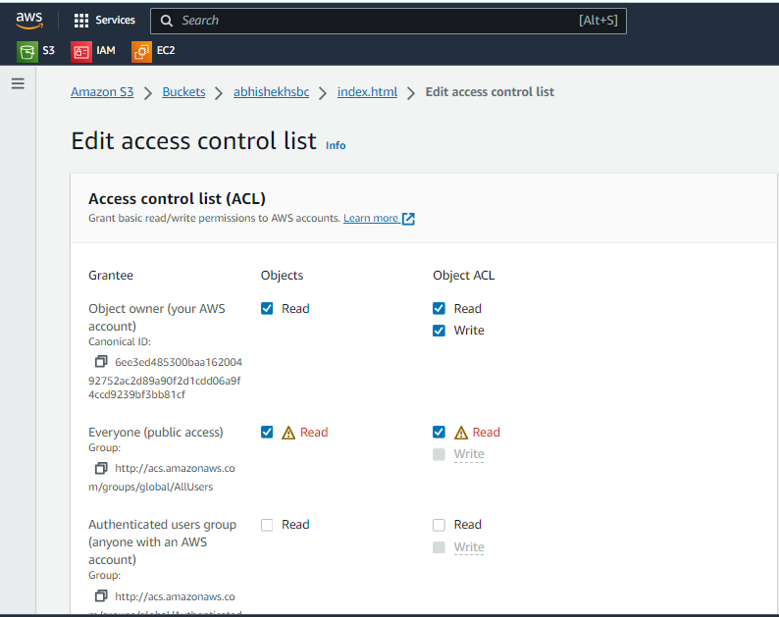

**Step 11: How to create error file (suppose any user type wrong url then error**

**message should display).**

S3 → bucket → abhishek(Bucket_name) → properties → edit static website hosting → create error.html file → save.

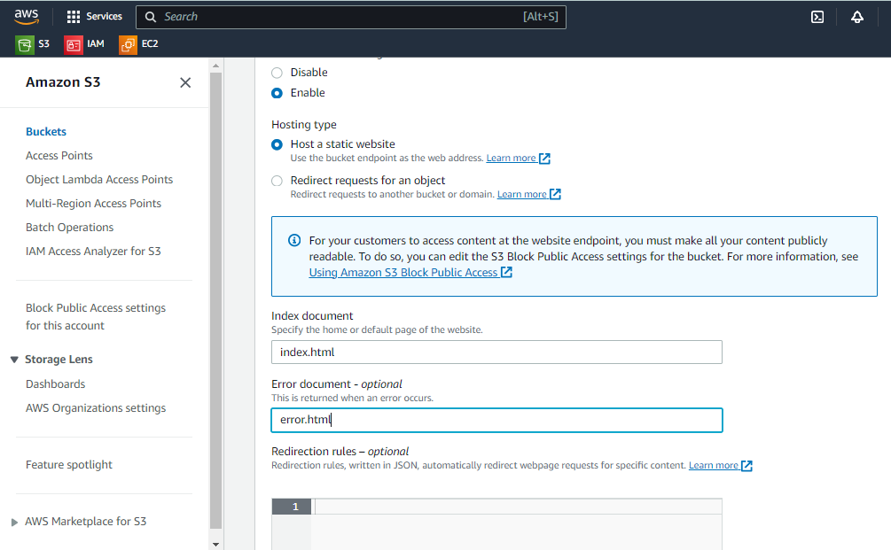

Step 12: create error.html file(you can create using visual code studio) in your local machine where we save our css template file.

Open index file in local using visual studio→ new file (in visual studio) → create error.html → and write error in that file which you want to print after entering wrong url.

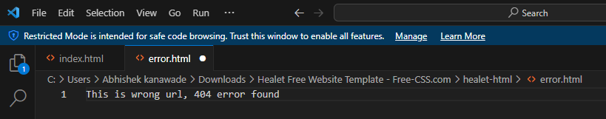

Step 12: Upload error file in bucket.

S3 → bucket → abhishek → upload error file from local → make it public file.

Step 13: Type wrong url on google then it will show error.

